Steven Ha

Kimberly Sandoval

Noelle Nordgren

Robin Slaiwa

MIS380 Thurs 4:00-6:30pm

Team 3 Project

1 STEP 1: Topic/Domain Selection

Selection of the domain you will be working on. Proper study and knowledge of the domain is necessary.

Some of the outputs from this step is listed below (but not limited to this):

• Selected Topic/Application: students need to come up with a topic or application or service. The best topic is the one that you have extensive knowledge about (i.e., related to your job, can gain knowledge through your family or friends). Also, if you have a business idea (e.g., startup business, mobile application, etc.) and have passion about that, it is a great idea to start working on that through this project and have a prototype at the end.

• Introduction: Students need to provide detailed explanation about the topic that they selected and

The Application chosen is Online Media Rentals. We are now living in a digital world where we can purchase almost anything online. One of the online purchases that can be made is movie rentals. Online Media Rentals is a business within the market of online movie rentals. It allows consumers to buy or rent movies online. Consumers can sit at the convenience of their homes and will be able to choose a variety of categories. Within the business, consumers can start by creating a membership online by providing their name and address. Their membership account will keep track of their fees and current balances. Upon creating an account, the consumer will have access to a variety of movie rentals within different genres, titles, and release dates. Upon choosing a rental, their account will advise on the fee, due date, return date, and any late fees.

• Advantages and contributions: Include all the advantages of having this database management system. At least mention 3 advantages.

1. Some advantages as a consumer is its convenience. Consumers can purchase a movie or TV show at any location. It eliminates the need to travel to the store to purchase a rental. Instead, consumers can purchase a movie at the comfort of their own homes.
2. It saves money as the consumer. A consumer can watch endless movies throughout the membership and lower costs per each movie.
3. It saves money as a business. It avoids the costs of maintaining building expenses such as utilities. It also saves on the costs of labor expenses.

• Uses cases: Include all industries/places/areas where this can be used or any business that have systems similar to your devised database.

There are numerous of businesses that use online media rentals which has made an impact in the business industry. Technology has expanded throughout the years and will continue to be a powerful source of revenue for businesses. Examples of such are: Amazon Prime Video, Netflix, Apple Tv, and FandangoNow. These media businesses are able to collect the user’s information by collecting their email address, name, and payment information. Most of the movie rentals have different types of options for consumers to purchase from such as “no ads” or “monthly subscription.” Consumers are able to successfully purchase or rent movies that fits their budget but also their preference in the type of movies they want to watch. Being in a subscription with online rentals has changed the way individuals watch movies due to them having more authority to choose their movie preferences. Fortunately, this database is essential and “home” to millions of people because it is at their convenience.

2 STEP 2: Conceptual Data Modeling and Database Design

All logical diagrams like ER diagrams, EER diagrams should be made in the Database Design. The output for

this step are listed below:

• List of Business Rules: Group members need to start by preparing a complete list of business rules relating to the selected topics.

* A membership can hold zero or many rentals
* A rental will belong to only one membership at a time
* Rentals will have one or many details
* The DetailRentals will have only one video
* The video will only show one movie
* The movie will have zero or one price.
* The cost of a movie will have none or many prices

• Conceptual Data Modeling: ER/EER Diagram: Find the list of involved entities, the relationship among them and draw the entity-relationship (ER) diagram. Please don’t forget to show the main concepts in the diagram such as supertype/subtype, cardinality, type of attributes, associative entity, etc.

• Transform ER/EER Model to Relational Model: Transform the developed ER/EER into a relational model using methods learned in the class. Please show all primary and foreign keys and references to other tables.

• Normalization: Check the tables (If necessary): Check the final relations (tables) for dependencies and perform normalization if required to have well-defined tables.

Answer/

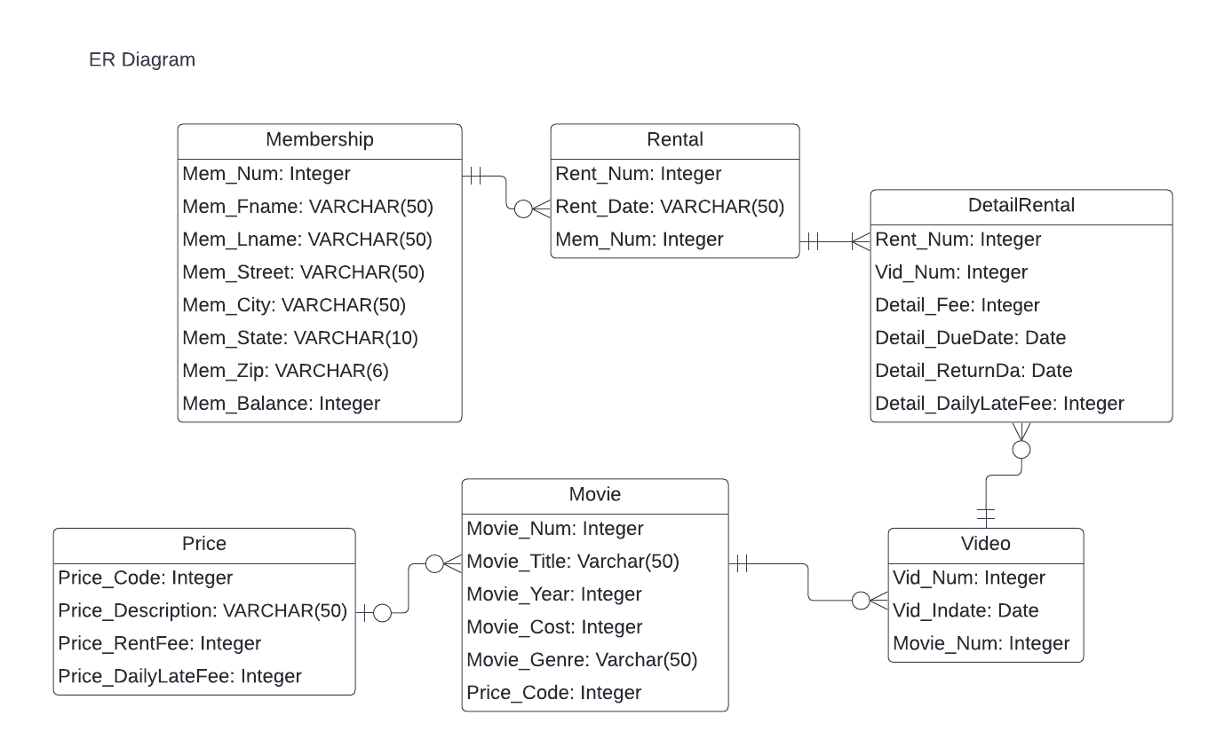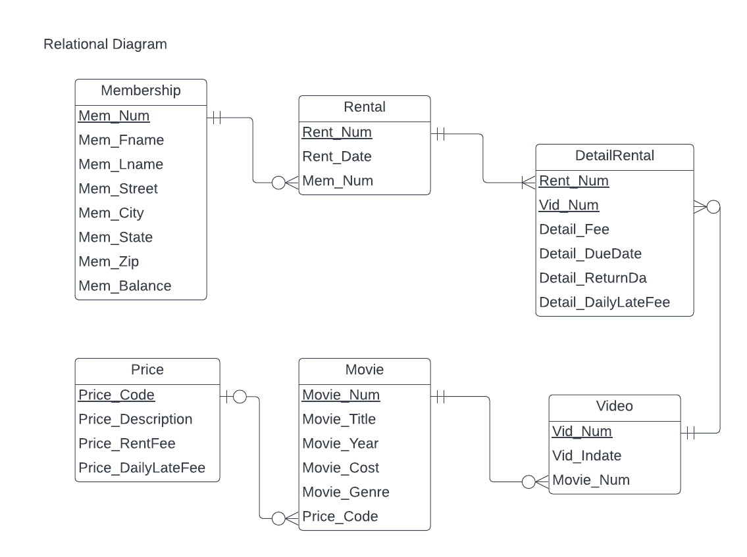

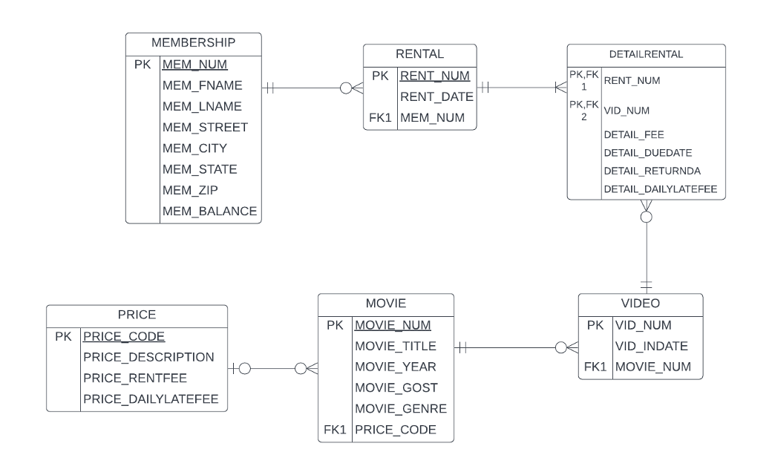

3 STEP 3: Database Implementation

The output for this step are listed below:

• DDL SQL statements to create Tables, views, indexes, etc.

• Insert dummy (fake) data into tables

• Prepare analytic questions (single and multi table) and develop related SQL statements.

Answer/ Use SQLITE

CREATE TABLE MEMBERSHIP (

MEM_NUM INT NOT NULL,

MEM_FNAME VARCHAR(50),

MEM_LNAME VARCHAR(50),

MEM_STREET VARCHAR(50),

MEM_CITY VARCHAR(50),

MEM_STATE VARCHAR(10) DEFAULT 'GA',

MEM_ZIP VARCHAR(6),

MEM_BALANCE INT,

PRIMARY KEY(MEM_NUM)

)

CREATE TABLE MOVIE (

MOVIE_NUM INT NOT NULL,

MOVIE_TITLE VARCHAR(50),

MOVIE_YEAR INT,

MOVIE_COST INT,

MOVIE_GENRE VARCHAR(50),

PRICE_CODE INT,

PRIMARY KEY(MOVIE_NUM),

CONSTRAINT Check_Movie_Cost CHECK (MOVIE_COST > 0),

CONSTRAINT Movie_Title UNIQUE (MOVIE_TITLE),

CONSTRAINT Price_fk FOREIGN KEY (PRICE_CODE) REFERENCES PRICE (PRICE_CODE)

)

CREATE TABLE RENTAL (

RENT_NUM INT NOT NULL,

RENT_DATE DATE,

MEM_NUM INT,

PRIMARY KEY(RENT_NUM),

FOREIGN KEY (MEM_NUM) REFERENCES MEMBERSHIP(MEM_NUM)

)

CREATE TABLE VIDEO (

VID_NUM INT NOT NULL,

VID_INDATE DATE,

MOVIE_NUM INT,

PRIMARY KEY(VID_NUM),

FOREIGN KEY (MOVIE_NUM) REFERENCES MOVIE(MOVIE_NUM)

)

CREATE TABLE DETAILRENTAL (

RENT_NUM INT NOT NULL,

VID_NUM INT NOT NULL,

DETAIL_FEE INT,

DETAIL_DUEDATE DATE NOT NULL,

DETAIL_RETURNDATE DATE,

DETAIL_DAILYLATEFEE INT,

PRIMARY KEY (RENT_NUM, VID_NUM),

FOREIGN KEY (RENT_NUM) REFERENCES RENTAL(RENT_NUM),

FOREIGN KEY (VID_NUM) REFERENCES VIDEO(VID_NUM)

)

CREATE TABLE PRICE (

PRICE_CODE INT NOT NULL,

PRICE_DESCRIPTION VARCHAR(50),

PRICE_RENTFEE INT NOT NULL,

PRICE_DAILYLATEFEE INT,

PRIMARY KEY(PRICE_CODE)

)

INSERT INTO MEMBERSHIP VALUES (102, 'TAMI', 'DAWSON', '2632 TAKLI CIRCLE', 'NORENE', 'TN', '37136', 11);

INSERT INTO MEMBERSHIP VALUES (103, 'CURT', 'KNIGHT', '4025 CORNELL COURT', 'FLATGAP', 'KY', '41219', 6);

INSERT INTO MEMBERSHIP VALUES (104, 'JAMAL', 'MELENDEZ', '788 EAST 145TH AVENUE', 'QUEBECK', 'TN', '38579', 0);

INSERT INTO MEMBERSHIP VALUES (105, 'IVA', 'MCCLAIN', '6045 MUSKET BALL CIRCLE', 'SUMMIT', 'KY', '42783', 15);

INSERT INTO MEMBERSHIP VALUES (106, 'MIRANDA', 'PARKS', '4469 MAXWELL PLACE', 'GERMANTOWN', 'TN', '38183', 0);

INSERT INTO MEMBERSHIP VALUES (107, 'ROSARIO', 'ELLIOTT', '7578 DANNER AVENUE', 'COLUMBIA', 'TN', '38402', 5);

INSERT INTO MEMBERSHIP VALUES (108, 'MATTIE', 'GUY', '4390 EVERGREEN STREET', 'LILY', 'KY', '40740', 0);

INSERT INTO MEMBERSHIP VALUES (109, 'CLINT', 'OCHOA', '1711 ELM STREET', 'GREENEVILLE', 'TN', '37745', 10);

INSERT INTO MEMBERSHIP VALUES (110, 'LEWIS', 'ROSALES', '4524 SOUTHWIND CIRCLE', 'COUNCE', 'TN', '38326', 0);

INSERT INTO MEMBERSHIP VALUES (111, 'STACY', 'MANN', '2789 EAST COOK AVENUE', 'MURFREESBORO', 'TN', '37132', 8);

INSERT INTO MEMBERSHIP VALUES (112, 'LUIS', 'TRUJILLO', '7267 MELVIN AVENUE', 'HEISKELL', 'TN', '37754', 3);

INSERT INTO MEMBERSHIP VALUES (113, 'MINNIE', 'GONZALES', '6430 VASILI DRIVE', 'WILLISTON', 'TN', '38076', 0);

INSERT INTO RENTAL VALUES (1001, '01-MAR-2018', 103);

INSERT INTO RENTAL VALUES (1002, '01-MAR-2018', 105);

INSERT INTO RENTAL VALUES (1003, '02-MAR-2018', 102);

INSERT INTO RENTAL VALUES (1004, '02-MAR-2018', 110);

INSERT INTO RENTAL VALUES (1005, '02-MAR-2018', 111);

INSERT INTO RENTAL VALUES (1006, '02-MAR-2018', 107);

INSERT INTO RENTAL VALUES (1007, '02-MAR-2018', 104);

INSERT INTO RENTAL VALUES (1008, '03-MAR-2018', 105);

INSERT INTO RENTAL VALUES (1009, '03-MAR-2018', 111);

INSERT INTO PRICE VALUES (1, 'Standard', 2, 1);

INSERT INTO PRICE VALUES (2, 'New Release', 3.5, 3);

INSERT INTO PRICE VALUES (3, 'Discount', 1.5, 1);

INSERT INTO PRICE VALUES (4, 'Weekly Special', 1, .5);

INSERT INTO MOVIE VALUES (1234, 'The Cesar Family Christmas', 2016, 39.95, 'FAMILY', 2);

INSERT INTO MOVIE VALUES (1235, 'Smokey Mountain Wildlife', 2013, 59.95, 'ACTION', 1);

INSERT INTO MOVIE VALUES (1236, 'Richard Goodhope', 2017, 59.95, 'DRAMA', 2);

INSERT INTO MOVIE VALUES (1237, 'Beatnik Fever', 2016, 29.95, 'COMEDY', 2);

INSERT INTO MOVIE VALUES (1238, 'Constant Companion', 2017, 89.95, 'DRAMA', NULL);

INSERT INTO MOVIE VALUES (1239, 'Where Hope Dies', 2007, 25.49, 'DRAMA', 3);

INSERT INTO MOVIE VALUES (1245, 'Time to Burn', 2014, 45.49, 'ACTION', 1);

INSERT INTO MOVIE VALUES (1246, 'What He Doesn''t Know', 2015, 58.29, 'COMEDY', 1);

INSERT INTO VIDEO VALUES (54321, '18-JUN-2017', 1234);

INSERT INTO VIDEO VALUES (54324, '18-JUN-2017', 1234);

INSERT INTO VIDEO VALUES (54325, '18-JUN-2017', 1234);

INSERT INTO VIDEO VALUES (34341, '22-JAN-2016', 1235);

INSERT INTO VIDEO VALUES (34342, '22-JAN-2016', 1235);

INSERT INTO VIDEO VALUES (34366, '02-MAR-2018', 1236);

INSERT INTO VIDEO VALUES (34367, '02-MAR-2018', 1236);

INSERT INTO VIDEO VALUES (34368, '02-MAR-2018', 1236);

INSERT INTO VIDEO VALUES (34369, '02-MAR-2018', 1236);

INSERT INTO VIDEO VALUES (44392, '21-OCT-2017', 1237);

INSERT INTO VIDEO VALUES (44397, '21-OCT-2017', 1237);

INSERT INTO VIDEO VALUES (59237, '14-FEB-2018', 1237);

INSERT INTO VIDEO VALUES (61388, '25-JAN-2016', 1239);

INSERT INTO VIDEO VALUES (61353, '28-JAN-2015', 1245);

INSERT INTO VIDEO VALUES (61354, '28-JAN-2015', 1245);

INSERT INTO VIDEO VALUES (61367, '30-JUL-2017', 1246);

INSERT INTO VIDEO VALUES (61369, '30-JUL-2017', 1246);

INSERT INTO DETAILRENTAL VALUES (1001, 34342, 2, '04-MAR-2018', '02-MAR-2018', NULL);

INSERT INTO DETAILRENTAL VALUES (1001, 34366, 3.5, '04-MAR-2018', '02-MAR-2018', 3);

INSERT INTO DETAILRENTAL VALUES (1001, 61353, 2, '04-MAR-2018', '03-MAR-2018', 1);

INSERT INTO DETAILRENTAL VALUES (1002, 59237, 3.5, '04-MAR-2018', '04-MAR-2018', 3);

INSERT INTO DETAILRENTAL VALUES (1003, 54325, 3.5, '04-MAR-2018', '09-MAR-2018', 3);

INSERT INTO DETAILRENTAL VALUES (1003, 61369, 2, '06-MAR-2018', '09-MAR-2018', 1);

INSERT INTO DETAILRENTAL VALUES (1003, 61388, 0, '06-MAR-2018', '09-MAR-2018', 1);

INSERT INTO DETAILRENTAL VALUES (1004, 34341, 2, '07-MAR-2018', '07-MAR-2018', 1);

INSERT INTO DETAILRENTAL VALUES (1004, 34367, 3.5, '05-MAR-2018', '07-MAR-2018', 3);

INSERT INTO DETAILRENTAL VALUES (1004, 44392, 3.5, '05-MAR-2018', '07-MAR-2018', 3);

INSERT INTO DETAILRENTAL VALUES (1005, 34342, 2, '07-MAR-2018', '05-MAR-2018', 1);

INSERT INTO DETAILRENTAL VALUES (1005, 44397, 3.5, '05-MAR-2018', '05-MAR-2018', 3);

INSERT INTO DETAILRENTAL VALUES (1006, 34366, 3.5, '05-MAR-2018', '04-MAR-2018', 3);

INSERT INTO DETAILRENTAL VALUES (1006, 61367, 2, '07-MAR-2018', NULL, 1);

INSERT INTO DETAILRENTAL VALUES (1007, 34368, 3.5, '05-MAR-2018', NULL, 3);

INSERT INTO DETAILRENTAL VALUES (1008, 34369, 3.5, '05-MAR-2018', '05-MAR-2018', 3);

INSERT INTO DETAILRENTAL VALUES (1009, 54324, 3.5, '05-MAR-2018', NULL, 3);

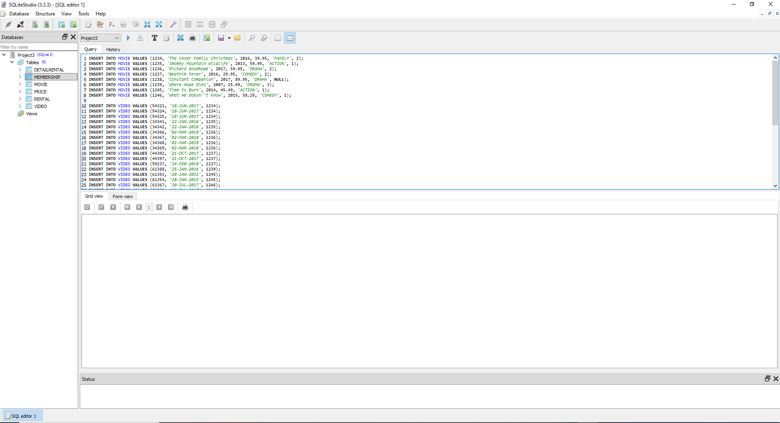

• Prepare analytic questions (single and multi table) and develop related SQL statements.

1- List the price description and rent fee for all of the different price types?

Select Mem_FName,Mem_LName, Rent_Date,Detail_Fee,Detail_DueDate

from Membership

inner join Rental on Membership.Mem_Num = Rental.Mem_Num

inner join detailrental on Rental.rent_Num = detailrental.Rent_Num;

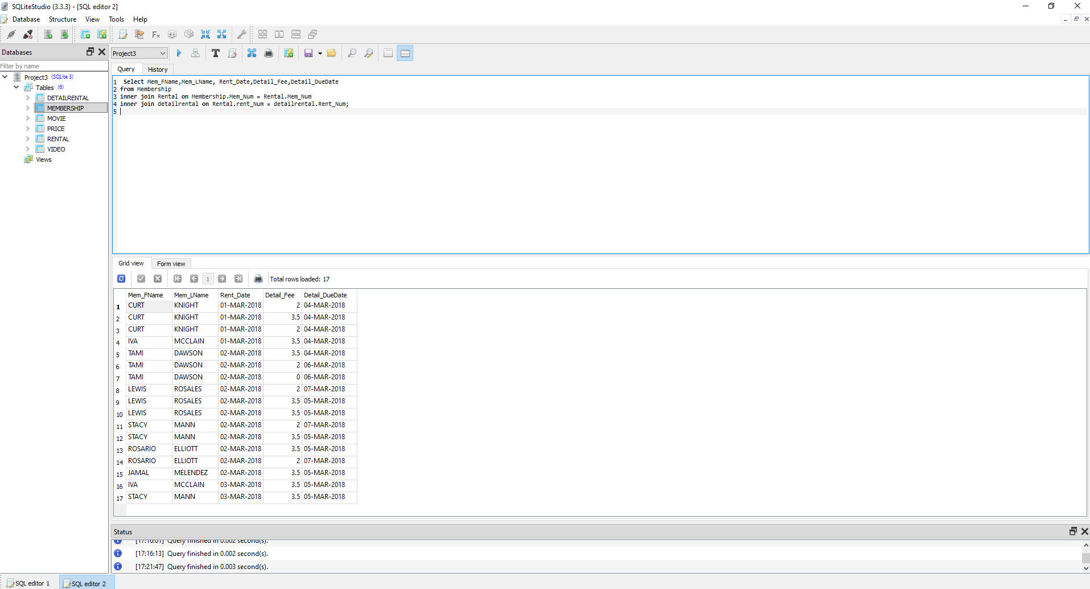

2- What was the highest fee paid by each member (report last name and fee). (use Inner Join, functions MIN Max and Group By)

SELECT MEM_NUM, MAX(DETAIL_FEE)

FROM RENTAL R JOIN DETAILRENTAL D ON R.RENT_NUM = D.RENT_NUM GROUP BY MEM_NUM;

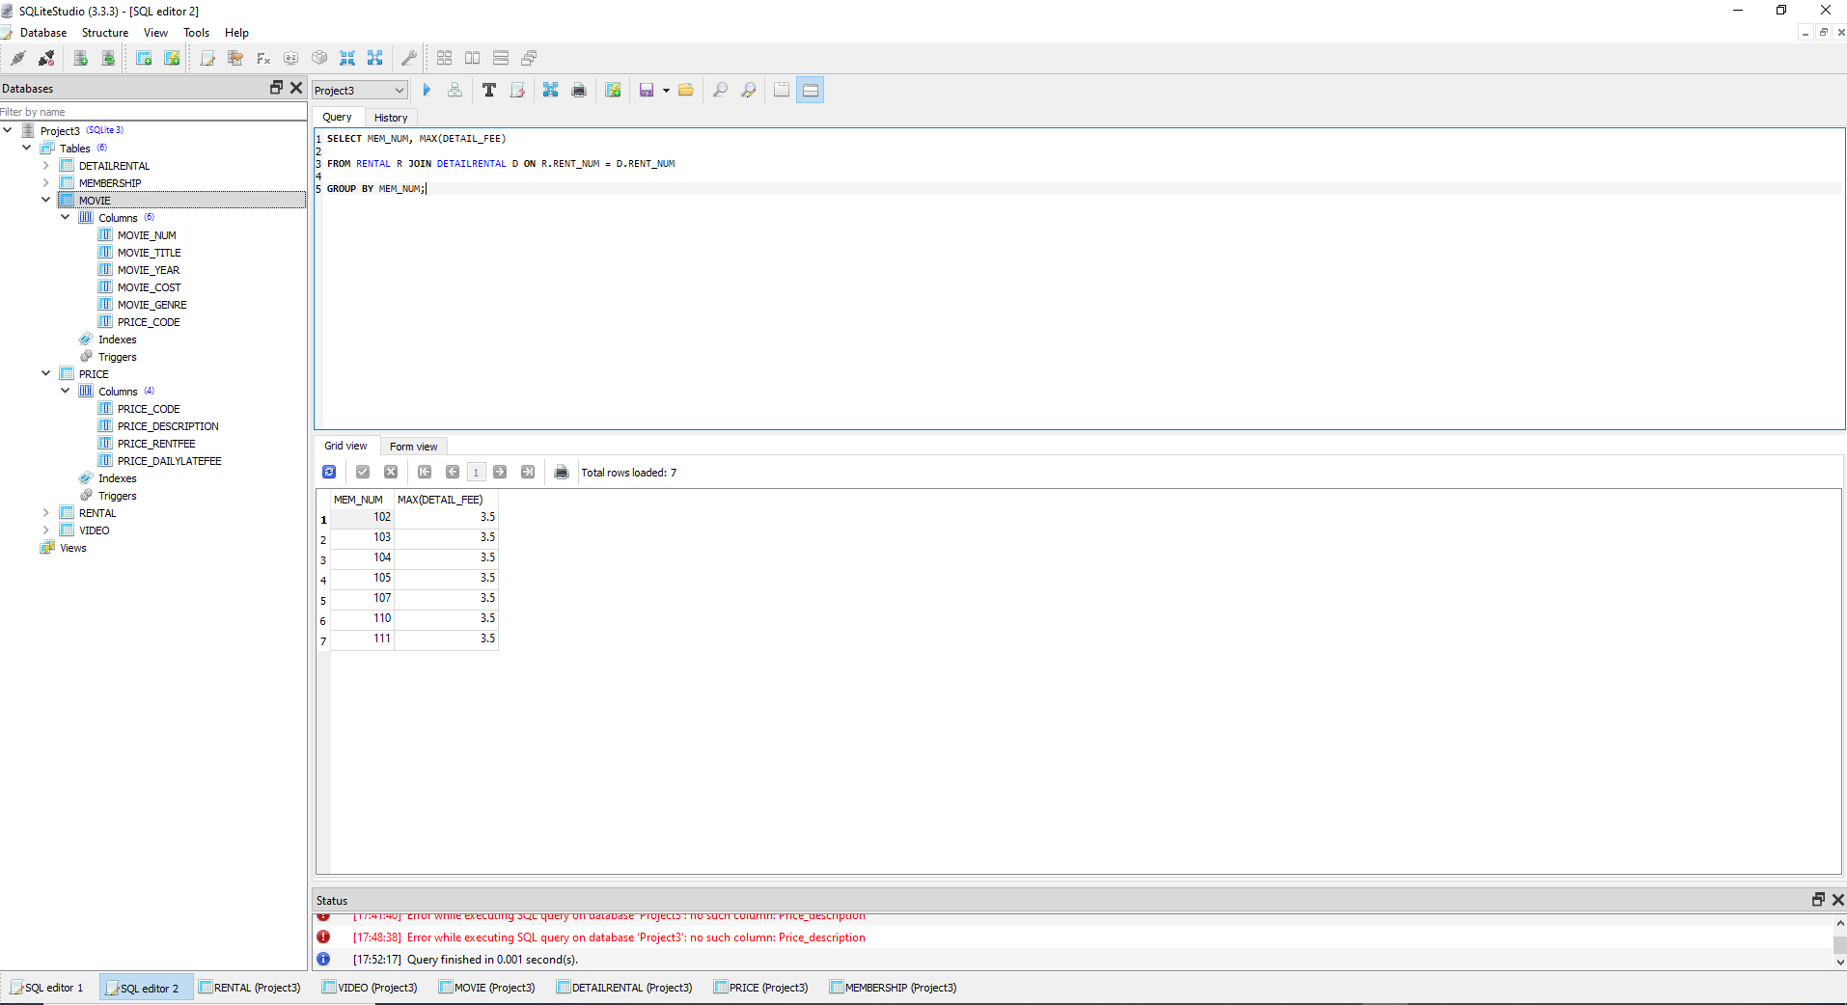

3- What are the movie titles, due dates and return dates for movies that have not been returned? (Null Values)

SELECT MOVIE_TITLE, DETAIL_DUEDATE, DETAIL_RETURNDATE

FROM MOVIE M JOIN VIDEO V ON M.MOVIE_NUM = V.MOVIE_NUM

JOIN DETAILRENTAL D ON V.VID_NUM = D.VID_NUM

WHERE DETAIL_RETURNDATE IS NULL;

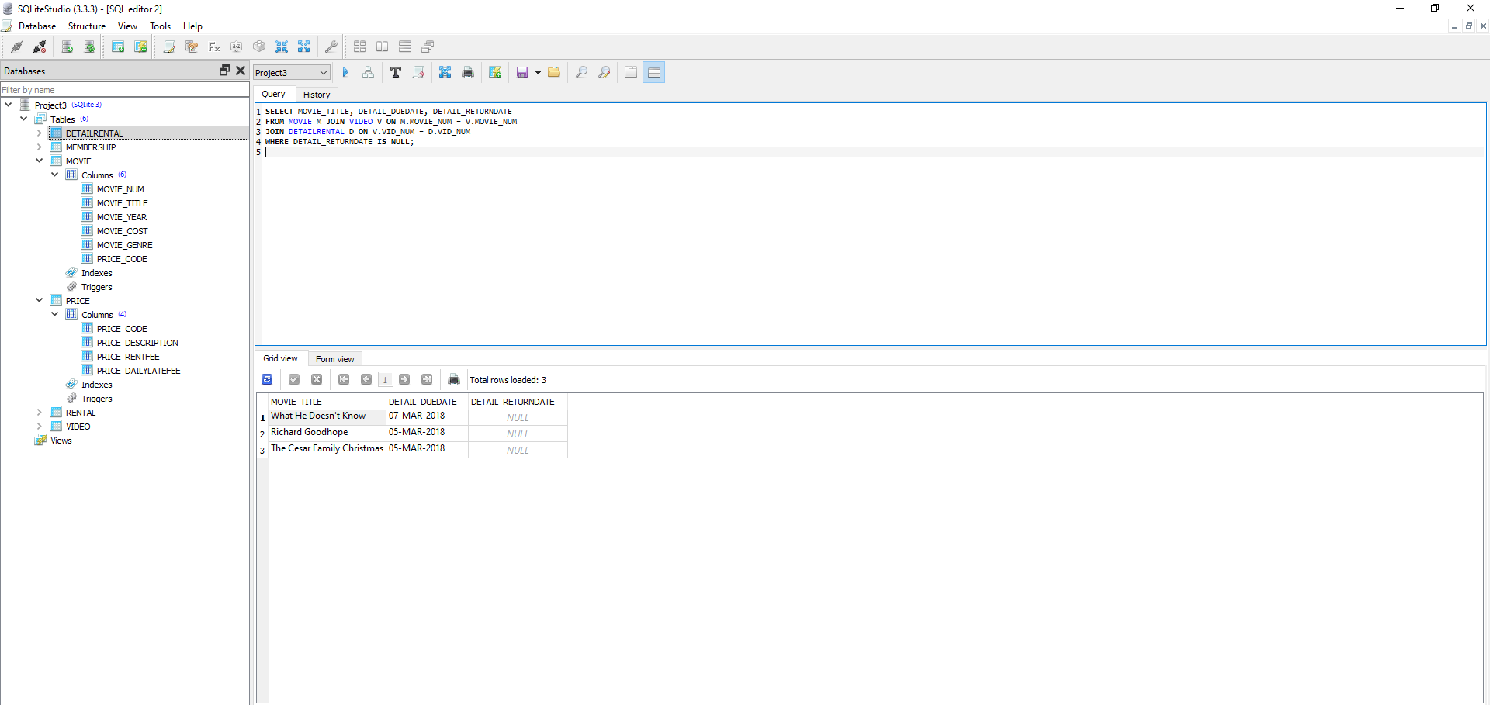

4- What were the total rental fees for members (report Mem_num) who total fees were greater than $5 - change the output label to “FeesMoreThan$5’? (use Inner Join, and SQL Functions count, Avg, Sum & SQL Group By & SQL Having)

SELECT MEM_NUM AS FeeMoreThan5$

FROM RENTAL R JOIN DETAILRENTAL D ON R.RENT_NUM = D.RENT_NUM

GROUP BY MEM_NUM

HAVING SUM(DETAIL_FEE)>5;

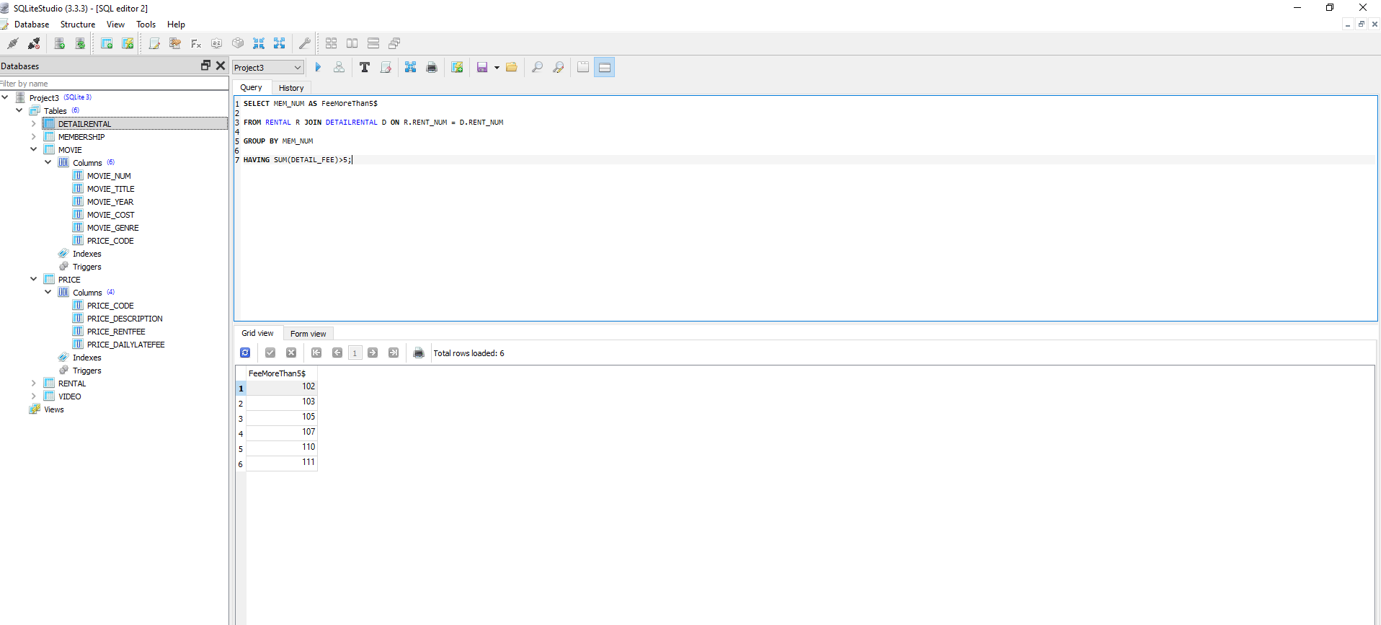

5- List the movie title for all new releases (use SQL Inner Join and SQL Where)?

Select Movie_Title

from Movie

inner join Price on Movie.Price_Code = Price.Price_Code

where UPPER(Price_description) = 'NEW RELEASE';

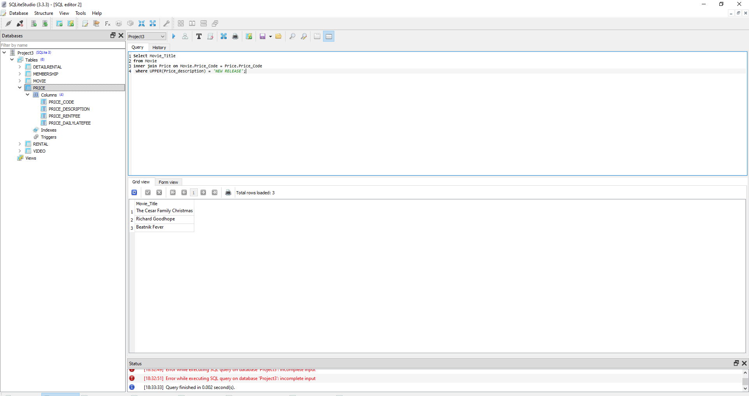

4 STEP 4: Enterprise (web) Database Dashboard

In this step, you will create a simple dashboard to illustrate the required analytics (e.g., from the previous

step). A sample dashboard for the music store database is available here ( Sample Dashboard (click here)).

For this step, you can find and use software, online services, or programming codes based on your knowl-

edge. Otherwise, you can follow the instructions and use the template python/sql codes and modify them

accordingly to create the dashboard.

<https://datapane.com/reports/43grvOA/interactive-dashboard-using-sql/>

